Advanced Algebra 2 Name___________________________Period______
Unit 2A Test
Answer Document

1._____ 13._____

2._____ 14._____

3._____ 15._____

4._____ 16._____

5._____ 17.__________________

6._____ 18._____

7._____ 19._____

8._____ 20._____
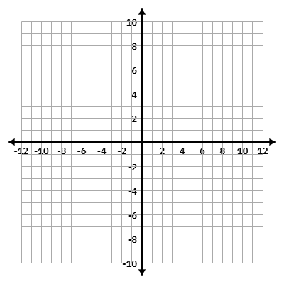
9._____ 21.

10._____

11._________________________________________

12.

22._____

23._____

24._____

25._____

26._____

27._____

28._____

